Milestone 4: Review Cycle, UI Integration, and Final System Deployment

1. Objective
The objective of this milestone is to implement a quality evaluation and refinement cycle, integrate all modules into a unified web interface, and finalize the system as a complete automated literature review platform.
This milestone focuses on usability, quality control, and system-level integration.
2. Review and Refinement Cycle Implementation
A review module was developed to simulate an academic peer-review process.
The module performs:
• Clarity assessment
• Logical flow evaluation
• Repetition detection
• Structural consistency review
• Strength of synthesis analysis
The critique is generated using a dedicated LLM prompt and returned in structured bullet-point format without rewriting the content.

3. Revision Generation Module
After critique generation, users can trigger a revision phase.
The revision module:
• Takes the original review and critique as input
• Improves clarity and coherence
• Removes redundancy
• Strengthens structure
• Preserves original meaning
This module creates a two-step professional review cycle similar to academic editing workflows .

4. Gradio-Based User Interface Integration
All modules were integrated into a unified Gradio interface to provide an interactive user experience.
UI Capabilities:
• Topic input field
• Full pipeline execution button
• Live pipeline status updates
• Display of final structured review
• Critique generation control
• Revision generation control

5. Final Report Preparation
The final structured review file generated in Milestone 3 serves as the consolidated research report for each topic.
It combines:
• Abstract
• Methods
• Results
• APA references
This file represents the final automated literature review output and fulfills the requirement of combining all generated sections into a single academic text file.

6. Final Testing and Validation
The complete system was tested under:
• Single-paper scenarios
• Multi-paper scenarios
• Duplicate topic re-runs
• UI-triggered critique and revision cycle

7. Output
Milestone 4 delivers a fully integrated, automated research review system with:
• End-to-end pipeline orchestration
• Structured academic writing
• Quality refinement cycle
• Interactive user interface
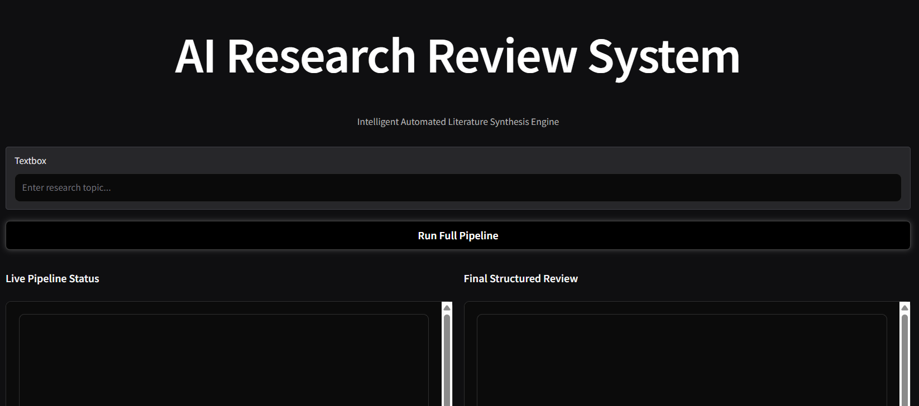
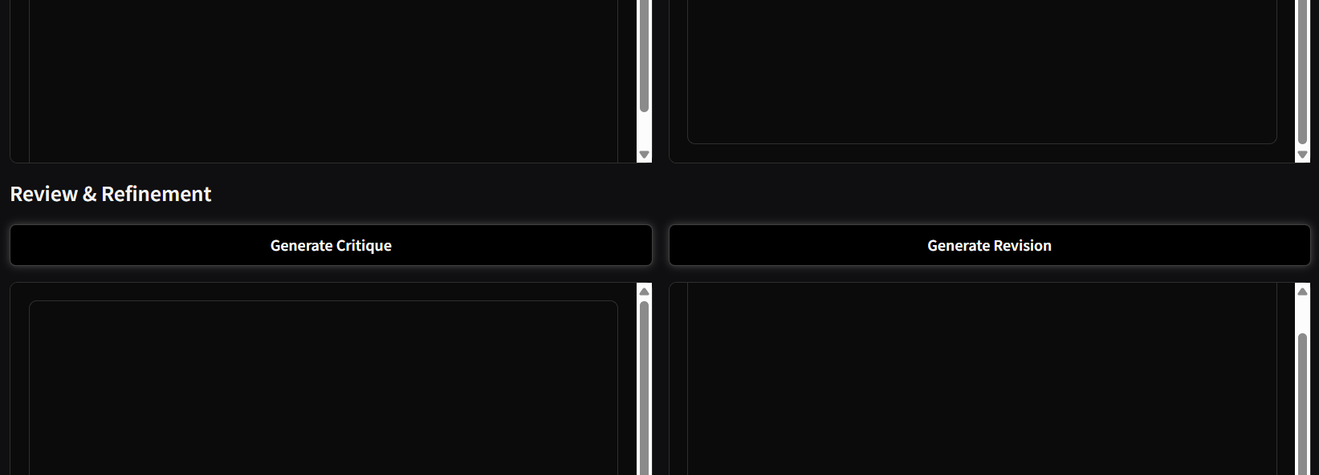

12. Conclusion
Milestone 4 finalizes the transformation of the project into a complete AI-powered literature review platform. The system now supports retrieval, semantic structuring, analytical synthesis, structured writing, peer-style review, and interactive deployment — achieving full project objectives.

